**CHAPTER ONE**

**INTRODUCTION**

**1.1 Background of the Study**

One of the greatest difficulties we face in the present time is the development of renewable energy resources, which can supplement the challenged fossil fuels of present time. Solar energy that can be used in different form is definitely the most important among all other renewable sources of energy. This is true because, every hour, the earth receives more energy from the sun than is consumed by mankind in a year, (Patz *et al.,*1983). The energy that is transferred from the Sun as a radiant energy to the earth’s surface is known as a solar radiation. Solar radiation is used in many sectors such as drying crops in Agriculture, generation of electricity, house heating, and many other things (UNIDO, 2003). It is this energy that keeps us alive. The important thing about solar energy is that it is free of charge, exists in abundant, inexhaustible and non-pollutant. It is made to warm the earth and to give the wind and the weather. Without the sun’s radiant energy, the earth will gradually cool and becomes encased in a layer of ice.

Measurement of solar radiation per unit of surface (Wm-2) is called irradiance. Pyranometer is an instrument that is used for measuring solar radiation on a horizontal surface; it is also most used in meteorology, climatology, agriculture, solar energy studies, (Rai, 2006). The average solar energy is 3.7KWhm-2day-1 in tropical Nigeria and along the coastal areas is about 7.0KWhm-2day-1 along the semi-arid areas of the North. The Country on average receives solar radiation level of about 5.3KWhm-2day-1, (Nwankwo *et al.,* 2012). The best way of knowing the amount of solar radiation at a site is to install a pyranometer at many locations in a given region and look after their day to day maintenance (Medugu& Yakubu, 2011), however most researchers within the country use these available theoretical values of meteorological data to compute average irradiance of solar radiation for different location within Nigeria, they lack standard measured data obtained from reliable measuring instrument suitable for their local environment and therefore resorted to theoretical prediction using different models for global daily sunshine radiation. There are several examples of such models in the Nigeria environment, (Fagbenle 1983; Doyle and Sambo 1985; Burari and Sambo 2001; Onah and Osuji 2007; Ejeh and Itodo 2010; Augustine and Nnabuchi2009; Agbo and Ezema 2009; and Taiwo 2010).

**1.2 Statement of The Problem**

Absence of irradiance data in a region or an area is one of the major causes of failure of solar farm installations; in this sense, knowing the levels of radiation during the course of the day for a particular area or region is of vital importance for predicting the total convertible solar energy for usage. Therefore, the need for wireless collection of authentic radiance data for comparative evaluation with the theoretical predicted results given by previous researchers become a necessity, coupled with the fact that researchers in the past manually collect irradiance data from the field by being physically present. This major reason among many others prompted the emergence of this research.

**1.3Aim and Objectives of the Study**

The aim of this study is to construct a wireless solar radiation monitor with data logger.

The objectives are as follows:

1. To construct and test the wireless solar radiation sensor for performance appraisal.

**1.4 Scope and Limitation of the Study**

The work will deal with developing a hardware to detect solar radiation and wirelessly transmit the data to a microcontroller for display and data logging. Data acquisition will be using a solar photovoltaic module, a simple circuit arrangement for monitoring the developed voltage and current via a voltage/current sensor module. The processing will be done by the Arduino microcontroller while the data transmission will be by the transmitter/receiver module. The limitations of this work are that the calibration process needs care for correct data. Also, the distance limitation of the radio transmitter/receiver module set limits the distance of data transmission to 200m.

**1.5 Theoretical Concept**

According to Planck’s law, the Sun is a nuclear reactor that generates energy mainly due to the solar surface temperature. The electromagnetic spectrum of the sun light includes wavelengths coming from the infrared to the ultraviolet. This spectral range of electromagnetic is called Solar Radiation (Fernando *et al.,* ,2014). Solar radiation is good for every living things and all resources. It determines the rate of photo synthesis in plants and strongly regulates the amount of evaporation from rivers and streams. It warms our planet and gives us our everyday wind and weather (Asiegbu, 2014). There are mainly three types of devices to measure solar radiation over the Earth´s surface: Pyranometers (direct and diffuse solar irradiance), Pyrheliometers (direct solar irradiance) and Albedometers (reflected solar irradiance) (Fernando *et al.,*, 2014). Pyranometer is an instrument use for measuring solar radiation on a horizontal surface. Pyranometers are widely used in meteorology, climatology, agriculture, solar energy studies and building physics. The constructed pyranometer can be used in any installation where reliable measurement of solar irradiance is necessary, especially in those places (like institutions) where cost may be a deciding factor in the choice of a meter (Medugu*et al.,*2010).

** (2)**

And

** (3)**

** (4)**

G is the irradiance (W/m2) and G* is the irradiance at STC (1000 W/m2). ΔI is the changes in module current due to variation of climatic conditions with respect to its STC values (A). ΔV is the changes in module voltage due to variation of climatic conditions with respect to its STC values (V). Ki is a short-circuit current temperature coefficient (A/°C) and KV is an open-circuit voltage temperature coefficient (V/°C). Rs is a series resistance or load (􀂟). I*mp is a current at the maximum power at STC (A) and V*mp is a voltage at the maximum power at STC (V).

**CHAPTER TWO**

**2.0 Literature Review**

**2.1 Review of Related Work**

Ahmad *et al.,* (2021), have designed A Simple and Inexpensive Irradiance Monitoring System Using Photovoltaic Panel*.* They have stated that monitoring of the solar irradiance is important because of sure data may correlate with many disciplines. The developed irradiance monitoring instrument has the ability to monitor the using of a photovoltaic panel as the sensor. In this principle, the instrument known as photovoltaic panel produces electricity if it is exposed to direct sunlight and its output is proportional to the irradiance. The output is read by a microcontroller and it is calculated using an algorithm to estimate the irradiance value. This study is started by designing the hardware both the electronic parts including a microcontroller, radio transceiver, data logger, and the mechanical parts including the pole and the active solar tracker. The software is designed and developed using the Arduino IDE. Generally, the result shows that the photovoltaic panels can be used as a sensor to measure the irradiance. It is equipped with the active solar tracking system to keep the photovoltaic panel perpendicular to the incident sunbeam. The electronic control box is made from outdoor electronic junction enclosure.

The instrument is designed to read the irradiance data by installing it side by side with the Standard Automatic Solar Radiation Station (ASRS) in the Meteorological, Climatological and Geophysical Agency (BMKG) Station in Bengkulu. The experiment has shown that data has been logged from 12 am to 12 pm with 10 minutes’ automatic interval of reading as the ASRS also logs the data automatically in 10 minutes daily. For the purpose of data analysis and error calculation and reliability of the instrument, the data has been logged at different weather condition. The logged data is plotted against measurement data from the standard instrument. From the result it could be seen that the developed instrument is worked properly because the data follows the trend of the ASRS data.

Paola *et al.,* (2019) designed and implemented an UV Radiation Monitoring System for The Neiva-Huila Municipality. In their research, it was stated that exposure to solar Ultraviolet (UV) radiation causes of skin cancer in people; because of that and knowing the levels of radiation during the course of the day is of vital importance for all outdoor activities. The developed system allows knowing in real time the index of ultraviolet tradition in the municipality of Neiva. The system recorded information that are found in database and deployed in web application; it keeps the record of present and past captured by the system. In addition, through a mobile application this information can be accessed in real time and create alarms that alert users when the UV radiation index exceeds a pre-defined value by the user. Finally, in order to sustain the reliability of the system, a validation of the system was carried out, comparing the data obtained by the designed system with the data from the Institute of Hydrology, Meteorology and Environmental Studies (in Spanish IDEAM) automatic weather station, generating high expectations in the operation of the designed system under normal environmental conditions.

John *et al.,* (2019) designed and implemented an electronic pyranomter purposely to reduce the expenses and innovative ideas to resolve empirical problems. The pyraometer was created with a solar panel that charges the battery through a charge controller and the battery powers the electronic pyranometer circuit. The electronic pyranometer circuit was designed using a solar radiation equation Rs which was programmed into to an Atmega328p microcontroller with J (latitude) been inputted manually according to location and the maximum/minimum solar temperature measured through DHT11; a temperature and humidity sensor, and all parameters are inputted into the Rs formula to calculate the average solar radiation at a particular time. The SD CARD module was used in this design in order to keep the record of electromagnetic solar radiation which is calculated by the microcontroller in a text format with a real time clock module (RTC module) that interface with microcontroller through Inter Integrated Circuit (IIC or I2C); It was used to keep track of the days’ use in the determination of the solar radiation and the temperature sampling rate. A liquid crystal display (LCD) was used display of all the necessary information required by the user. Once the pyranometer was tested, the result recommended the improvemention the types of sensors and packaging.

Mugur *et al.,* (2018) have presented the results on design and Implementation of a solar Radiation Monitoring System of which they use two scientific pyranometers and an online computer home-made data acquisition system. The first pyranometer measures the global solar radiation and the other one, which is shaded, measure the diffuse radiation. The values of total and diffuse solar radiation are continuously stored into a database on a server. There is specific software that was created for data acquisition and interrogation of the created system. At every 50 seconds the server application receives the data from pyranometers and stores it into a database. The client-server application saves the database with all the statistics descriptions. Through the web interface any user can access the data and to obtain the results. the system can provide direct, diffuse and total radiation intensities as time series as its generated results. Even the derivative heat is also computed by client-server application. The ability of the system to evaluate the local solar energy potential is highlighted.

According to Christy & Amudha (2017) only little meteorological station that measures the availability of solar radiation. In many developing countries, like India, because of cost implication in maintenance and calibration requirements the measuring of the solar radiation is not easily done in place. In this aspect, it is important to estimate the solar radiation availability in meteorological, for design and efficient operation of solar energy system. Recently several empirical formulas using various parameters are considered to estimate the solar radiation around the world. Several statistical models and computational algorithms are used for estimating the solar radiation. In this paper, investigations on prediction of global solar radiation are carried out and various computation algorithms used are discussed.

Nwankwo, &Nnabuchi, (2015) worked on variability of solar radiation data, their research focused on the variability of global solar radiation over the area of Abakaliki, Ebonyi State (6o20’N, 8o06’E) located in South Eastern part of Nigeria for the rainy and dry seasons. The Pyranometer used for this measurement was locally developed and calibrated against a standard pyranometer, it competed favorably with the standard Einstein Lungs Sensor. The global solar radiation was measured every five minutes from 08:00hours to 18:00hours during the dry season in 2011 and rainy season in 2012. The measurements were carried out near the New Physics Laboratory Complex Ebonyi State University Abakaliki, Nigeria. Maximum Irradiances of 1095.10Wm-2 and 689.48Wm-2recorded in Abakaliki during dry and rainy seasons respectively occurred between 12:00 –14:00 hours local time, whereas the minimum values of 9.20Wm-2 and 9.86Wm-2 respectively are recorded during the sunrise and sunset. Partly cloudy conditions in Abakaliki cause conspicuous oscillations in global solar radiation.

According to Ahmed *et al.,* (2019) photovoltaic cells are classified by static relationship that describes their current–voltage relationship. This relationship is a complicated implicit algebraic equation that depends, in a nonlinear way, on two critical uncertain parameters: temperature and solar irradiance. The efficient operation of the solar panel depends on the knowledge of these key parameters. It is technologically feasible to measure the old sensor, but latter is expensive and difficult to calibrate. Therefore, implementation of a low cost solar radiation (W/m2) meter becomes a substitute using photovoltaic panel as a sensor. Its meter is easy to use and can display immediately the sun radiation by the constantly controlling the open circuit voltage, short circuit current and temperature of the solar panel. This project is realized in order to replace the classical solar irradiance sensors (e.g. pyronometer), which are expensive. The instrument consists of a solar panel, a simple sensing circuit and a microcontroller based control unit. The performance of the meter is validated through detailed computer simulations and experimental prototyping using real outdoor measurements at different atmospheric conditions.

Mathew (2022) developed a cheap solar radiation detector. The detector uses a photodiode as sensor, an operational amplifier transimpedance amplifier and a controller to achieve irradiance measurement. The instrument was calibrated against a standard model. Results were encouraging to be acceptable as a reperesntation of the measured irradince at any point.

Consult &Onyemachi (2023) designed and implemented a thermocouple based pyranometer, coupled with a radiation sensor. The output from the pyranometer is fed into a sensitive long scale galvanomer. The advantage of this system is that the reading is not seriously affected by mall changes in power supply. Also the thermopile was calibrated before assembling to give more accurate readings. This has the advantageof giving greater protective resistance to the casing against bad heat and weather, moreover the alluminium foil was coated with white paint and it was covered with white chalk particles and finally sealed with another+ aluminum foil. This has the advantage of making the reflector surface highly reflective.

Muchamad& Andi (2022) developed a complex system for measuring the four solar radiation parameters: diffusion radiation, global radiation, direct radiation, and solar radiation duration which typically needs to use many devices. Their work was able to measure all four-radiation data by a single pyranometer with particular modification and shading device. Actuators, motors and shades were used to achieve that. This design results have a high correlation with a global standard with a value of R=0.73, diffusion with a value of R=0.60 and a sufficiently strong direct correlation with a value of R=0.56. It can be said that the system is much simpler, making it easier to monitor and log the various solar radiation parameters.

Tohsing *et al.,* (2021) developed a low-cost pyranometer for measuring broadband solar radiation. A BPX43 – 4 phototransistor is used to detect the light, in which the spectral response varies from 450 to 1100 nm. This system is achieved by Arduino pro mini ATmega328P (5 V, 16 MHz) microcontroller and all components are located inside a FB05 black box. The pyranometer is subject to voltage saturation due to the high level of solar radiation in different environmental conditions. Therefore, a 0.25 mm thick of Teflon is selected for attenuating the sunlight. After checking the reference of the sensor, the transmittance of this attenuator is found to be about 12.5%. Finally, the experimental results from the system are compared with a standard pyranometer performed at Physikalisch-Meteorologisches Observatorium Davos/World Radiation Center (PMOD/WRC, 46.80 oN, 9.83 oE and 1,610 meters above sea level), Switzerland. The results demonstrated a satisfactory agreement between the global irradiance obtained from our proposed pyranometer and the standard pyranometer.

Peter (2020) worked on a low-cost autonomous pyranometer was made by designing a low-cost pyranometer that is made autonomous by interfacing it with a low-cost autonomous weather station. Multiple sensors were used, and by way of sensor fusing, combining the data to measure the solar irradiance. This means that a sensor for every type of light is used, in the case of the system to be made, ultraviolet, visible light and infrared, after which the data of all are combined to get an overall solar irradiance. The sensor used off-the-shelf modules, a microcontroller and a Digital to Analog Converter to generate a voltage to be read by the low-cost autonomous weather station. The conversion of the output of the light sensors to a voltage that is outputted is done with the help of a calibration function made by a Multiple Linear Regression model. The overall sensor went through four different iterations to get to the end prototype.

The low-cost pyranometer was evaluated with the help of a reference pyranometer, the Davis Instruments Solar Radiation Sensor. The testing setup measured both outputs simultaneously while these pyranometers were outside in the sun. The low-cost pyranometer fulfilled the main requirements, which included accuracy and costs.

Orsetti*et al.,* (2016). presented an innovative low cost sensor and algorithm for the monitoring and measurement of solar irradiance. This parameter is usually estimated using pyranometers, often based on thermopile. They are quite expensive, also because need additional hardware for data acquisition and manipulation as well as non-negligible installation costs. The system architecture and novel algorithm here proposed employ small PhotoVoltaic (PV) cells and a digital sensor interface. Moreover, the logic section permits to tilt the sensor allowing to track the sun with improved accuracy.

Aakanksha*et al.,* (2013) developed a Photodiode Based Pyranometer. They presented the idea and design of a new photodiode-based pyranometer for the measurement of solar irradiance in the visible spectral range (approx. 400 to 750 nm). The principal characteristics of the proposed design are: accuracy, ease of connection, immunity to noise, remote programming and operation, interior temperature regulation, cosine error minimization and all this at a very low cost, tens of times lower than that of commercial thermopile-based devices. This new photodiode-based pyranometer overcomes traditional problems in this type of device and offers similar characteristics to those of thermopile-based pyranometers and, therefore, can be used in any installation where reliable measurement of solar irradiance is necessary, especially in those where cost is a deciding factor in the choice of a meter.

Macome*et al.,* (2009) presented the design, Construction and Characterization of a multiple Sensors Solar Radiation Detector for Ises 2009. The research work evaluated the use of a

weighted combination of photodiodes measurements with a rotating shadow band for monitoring simultaneously diffuse and beam solar radiation and thus be able to estimate global radiation as well. A set of four diodes with different spectral ranges is proposed as a first prototype. Three different Silicon diodes and one Indium Gallium Arsenide diode are the candidates. A simple signal preamplifier will be used to give signals in the one or few volt ranges that can be measured with any data logger. The diodes were mounted in a row parallel to the polar axis. Measurements was taken with and without shadowing with the diodes facing the sun, and in three other shadowed positions to estimate the diffuse component. The shadowing mechanism was automatically driven and positioned to intercept the direct solar radiation incident on the diodes. A microprocessor system will control the measurements as well as the movement of sensors and shadow band and record the data. The diodes were calibrated before actual measurements start.

Laghrouche*et al.,* (2010) worked on Design of a Microcontroller Based Automated Pyranometer. The work was done based on a microcontroller and can measure eight signals at programmable time intervals. The data are acquired from sensors are placed on a dome to monitor and measure the insolation during the whole day. Thanks to the technology used the system has a large autonomy of use, which allowed us to measure the sunlight with an accuracy of about 0.1%.

IoT-based solar irradiance measurement systems have revolutionized the way solar energy is harnessed and utilized. These systems leverage the power of Internet of Things (IoT) technology to accurately and continuously measure solar irradiance levels, providing crucial data for solar energy planning, optimization, and performance monitoring. One notable IoT-based solar irradiance measurement solution is the use of wireless sensor networks (WSNs) equipped with solar irradiance sensors. These sensors are deployed across solar farms or rooftop installations, gathering real-time data on solar irradiance levels. The collected data is then transmitted wirelessly to a central server or cloud platform for analysis and further processing. One research study conducted by Zhang et al. (2018) titled "Design and Implementation of an IoT-based Solar Irradiance Monitoring System" showcased the development of an IoT-based solar irradiance monitoring system. The study demonstrated how the system effectively measured and monitored solar irradiance levels using WSNs. Another study by Pandey et al. (2019) titled "Internet of Things Based Solar Irradiance Monitoring and Tracking System for Efficient Solar Power Generation" proposed an IoT-based solar irradiance monitoring and tracking system. The research highlighted how this system combined solar tracking mechanisms with IoT technology to enhance the efficiency of solar power generation by ensuring maximum exposure to sunlight by wirele monitoring of performance.

In conclusion, IoT-based solar irradiance measurement systems offer significant benefits in terms of accurate solar irradiance monitoring, storage, data analysis, and optimization.

References:

1. Zhang, X., Zhao, W., Li, P., Song, M., & Wang, X. (2018). Design and Implementation of an IoT-based Solar Irradiance Monitoring System. IEEE Access, 6, 17152-17160.

2. Pandey, A., Roy, A., Saha, A., & Singh, M. (2019). Internet of Things Based Solar Irradiance Monitoring and Tracking System for Efficient Solar Power Generation. In 2019 9th International Conference on Cloud Computing, Data Science & Engineering (Confluence) (pp. 472-477). IEEE.

From reviewed literature it appears that the commonest method for solar irradiance detection is using the photovoltaic cell as sensor (Ahmed *et al.,* ,2021) (John *et al.,*, 2019)(Nwankwo &Onyemachi, 2023)(Ahmed *et al.,*, 2019)(Orsetti*et al.,*, 2016), while several authors have used the photodiode photodiode as sensors (Mathew, 2022)(Peter, 2020)(AAkansha*et al.,* , 2013) and (Macome, 2009). Several authors have used multiple sensors such as (Peter, 2020), Tohsing*et al.,*, 2019) and (Largrrounche*et al.,*, 2010). The use of active tracker has also become popular by authors such as (Ahmed *et al.,*, 2021) (Orsetti*et al.,*, 2016) and (Macome*et al.,*, 2009). This research shares the same methodology of using PV cell as a sensor, is wireless in data handling and incorporates a data logger, making the technology accessible and affordable for a failing economy like Nigeria.

**2.2 Theoretical Review**

**2.2.1 Solar Radiation and Solar Irradiance**

The common definition for solar radiation is: “Energy radiated from the sun in the form of electromagnetic waves, including visible and ultraviolet light and infrared radiation” [9]. In short, it means that all electromagnetic radiation that is sent out by the sun is referred to as solar radiation.

However, there is another word for solar radiation which means something similar: solar irradiance. solar irradiance, defined as “The amount of electromagnetic energy incident on a surface per unit time per unit area.” (Stickler, 2011). This definition refers to electromagnetic energy, which is the solar radiation, that falls on a surface per a certain amount of time.

As you see, there is a subtle difference. This mostly consists of the fact that solar irradiance includes solar radiation, but not the other way around. Another definition for solar irradiance is: “The amount of solar radiation that falls on a surface per time”. Still, this difference is extremely important to take note of, as to not confuse the two terms in this report.

**2.2.2 Solar Irradiance Classification**

There are two classifications of the solar irradiance. This classification can be important as it could be covering the same range while using other names for it.

One classification, according to Bilbao *et al.,*. and Rösemann (Bilbao *et al.,* ,2015) (Roseman, 2004) is the division in ultraviolet light, visible light, and infrared light. The UV has wavelengths from 0.2 - 0.4 μm, the visible spectrum ranges within 0.39 - 0.77 μm and the Infrared portion is divided into two parts, the near IR light, 0.77 - 25 μm and the far IR light, 25 - 1000 μm. This division can be used in this project to narrow the search of different types of sensors, as these sensors are mostly distributed under this division.

A second classification, as mentioned by Solecki*et al., (2005)*, Bilbao *et al.,. (Roseman, 2004)* and Rösemann (Sticler, 2011) smeans that solar irradiance is divided into the shortwave and long wave electromagnetic radiation. The shortwave electromagnetic radiation is the most measured irradiance type for weather applications and is set from 300 nm to 3000 nm (Soleki, 2005), (WMO, 2012). The bigger part of this shortwave electromagnetic radiation can be seen in Figure 2 (Nick84, 2020). This second division is less needed than the first one. However, since the range of spectral interest covers the shortwave radiation, it is good to keep this definition as well.

**2.2.3 Types of Solar Irradiance to measure**

Apart from the fact that there are divisions based on electromagnetic wavelength in the Solar Irradiance Spectrum, there are also three main variables that you can measure when measuring solar irradiance on earth (WMO,212). These are Global Horizontal Irradiance (GHI), Diffuse Horizontal Irradiance (DHI) and Direct Normal Irradiance (DNI). Djen*et al.,. (Abreu et al.,, 2019)* note that GHI is the most commonly measured variable regarding ground-based meteorological stations. Abreu *et al.,. (Djenet al.,,1994)* state that the DNI plays an important role in the urban heat island effect. Since the GHI also entails the DNI, as GHI is the sum of DHI and DNI, it could be argued that measuring the GHI would be enough for this project as it also encapsulates the DNI. The different types of irradiances can be seen in Figure 3 (Aurora, 2020).

**2.2.4 Classification of the Pyranometers**.

The pyranometers are classified into different categories and base on their functions. The basic classifications are found in two categories: Pyranometers that convert solar radiation into electrical energy, and pyranometers that convert electromagnetic spectrum into thermal energy. There are two subcategories, and these are dependent on the type of outputs you see with most pyranometers of a type: Analog and digital output.

The taxonomy as will be used in this thesis can be seen in Figure 2.1.



Figure 2.1: Classifications of Pyranometers

**2.2.4.1 Thermal Energy Pyranometers**

Thermal Energy Pyranometers are pyranometers that use multiple thermoelectric junctions to generate a few microvolts per W/m2. This is then proportional to the temperature difference between the thermoelectric junctions. The difference is denoted as a junction, the sensor junction, and the other is a reference junction which is not in direct view of the electromagnetic energy.

**2.2.4.2 Thermopile-based Pyranometers**

The thermopile-based pyranometer often uses two thermopiles to measure the temperature difference. This difference in temperature can then be converted in the amount of energy that falls on the sensing element of the pyranometer. (Hiankley, 2017)

These types of pyranometers give an analogue signal out that is then converted into a value for the solar irradiance using a sensitivity value. Often this is done by computers, making it automated, to easily generate measurement values.

A positive aspect of these types of pyranometers is that they uniformly absorb the energy from across the short-wave solar spectrum (285 to 2800 nm). A negative aspect, however, is that they are dependent on how fast the sensor can cool down when there are clouds. These results are in a slower response time than electrical energy pyranometers (Thekarera, 1996). An overview of a thermopile-based pyranometer can be found in Figure 2 (Kipp&Zonen, 2020).



Figure 2.2: *A Thermopile-based Pyranometer – Taken from the CM6 Pyranometer from Kipp&Zonen (Kipp&Zonen, 2020).*

**2.2.4.3 Electrical Energy Pyranometers**

Electrical Energy Pyranometers are pyranometers that convert the electromagnetic energy from the sun into electricity by a type of pyranometer called Electrical Energy pyranometers. They generate a current that passes through a shunt resistor to easily convert the current into a voltage signal. This then results in a sensitivity of about a few microvolts per W/m2. Often a special type of plastic diffuser is used to generate a cosine response. (Hiankley, 2017)

A good cosine response means that a 1000 W/m2 which is perpendicular on the sensor is read as 1000 W/m2 and when it approaches from a 60-degree angle, it is read as 500 W/m2. This is important as it would otherwise be hard to compare to the reference system, which does have a cosine response.

**2.2.4.4. Photovoltaic-based Pyranometers**

Photovoltaic-based pyranometers use a photovoltaic cell, an example that is commonly known is a solar panel. This photovoltaic cell is used to measure the amount of energy that falls on the photovoltaic cell. These are often used to check the output of other photovoltaic cells, like a solar power plant. The photovoltaic cell works near short circuit condition and using this a current is generated which can be measured.

**2.2.4.5 Photodiode-based Pyranometers**

A photodiode-based pyranometer uses a photodiode to measure electromagnetic energy (Thaekara, 1976). A photodiode is a type of photovoltaic device that is optimized for sensing electromagnetic energy. It is often used with an amplifier to generate a voltage that is proportionate to the current generated by the photodiode. Examples of these are also given by (Benghanem, 2010) and (Mukaro,1997) since they use silicon solar cell pyranometers in their testing. An example is shown in Figure 3 (Martinez, 2009).



*Figure 2.3: A Photodiode-based Pyranometer – taken from the research of Martinez et al.,(2019)*

**CHAPTER THREE**

**MATERIALS AND METHODS**

**3.1 Chapter Overview**

In this project, it is intended to design, simulate and implement a wireless solar radiation monitor with data logger over the internet. In this design, a photovoltaic cell was used as the solar collector together with a microcontroller. The microcontroller was programmed to quantify the solar energy received and convert same to irradiation values by use of appropriate formulas. The detected irradiation values were transmitted wirelessly to a data logging center over the internet. Before the final design, the complete system was simulated and, in the simulation, the aims and objectives of this work is hoped to be achieved.

**3.2 Materials**

The materials used to achieve this work are displayed in table 3.1. below

Table 3.1. Materials

|  |  |
| --- | --- |
| S/N | Materials |
| 1 | Microcontroller (Arduino Nano) |
| 2 | Buzzer |
| 3 | Battery |
| 4 | Switch |
| 5 | Current/Voltage sensor |
| 6 | Radio (WIFI Module) |
| 7  8  9  10  11  12 | Fixed Resistors  Photovoltaic Module  VSPE software  Proteus 8.0 Professional  Arduino Integrated development environment version 1.8.8  Fixed capacitors |

**3.3 Method of Design**

The construction of this project is made of the materials that are mono crystalline panel as a sensor, a microcontroller unit (MCU) is set to read analog voltage/Current from panel in the loop function, there is a module called a wireless area network that transmits the data from the MCU to the computer server, accumulator as a power supply, the enclosure box and other electrical and mechanical parts. This research needs some tools such as a personal computer (PC) with Arduino IDE software to sketch the program to the MCU, in this case, Arduino Uno.

This research consists of five main stages; hardware design, software design, calibration and testing, result analysis, and conclusion. In order to develop an outdoor instrument, it is required to design tough hardware such as the mechanical part and the enclosure for electrical parts. A good algorithm is also needed to perform an efficient measurement using a microcontroller unit. Calibration and testing are required before the monitoring activity to ensure if the measurements work properly. After calibration and testing, the system performance will be compared to that of a standard pyranometer.

In actualizing this project, the block diagram of figure 3 and 4 was employed as a guide for the calculation and or selection of components values to be used.

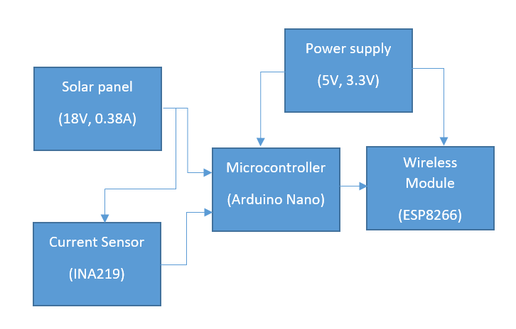

Figure 3.1: The block diagarm

**3.3.1 The Hardware Design**

The pyranometer will be designed for measuring solar radiation from a solid angle of 2 􀂟sr into a plane surface and a spectral range from 300 to 3000 nm, keeping in mind that the uncertainty of observations will increase when the sensor exposure conditions deviate from conditions in which the pyranometer was calibrated (Jarraud, 2012). The hardware used in this research consists of two main parts; electronic and mechanical part. The electronic part consists of a photovoltaic panel, MC, a wireless area network module, and power supply. The mechanical part consists of the entire body of the instrument including the enclosure box for the electrical part.

**3.3.1.1 The Electronic Section Design**

Figure 4 shows how the circuit is to be used along with the MCU in order to measure the electricity output properties from the photovoltaic panel. The INA 219 current-voltage sensor module will be used to measure it, instead of the analog input pin of the MCU.



*Figure 3.1: The basic method for solar radiation sensing*

Based on the previous research, the LDR and photodiode present a slow response and their spectral responses are narrow therefore it is not suitable for solar radiometry (Tharamuttan, 2017). The phototransistor has a wider but it is not considered to be used because the response of the PT202C only covers from 0.5 to 5 mW/cm2. It means that the maximum irradiance that can be measured is only 50 W/m2 (Ever light Electronics, 2015) that is why a photovoltaic panel is used, a mono crystalline photovoltaic panel has a wide spectral response from approximately 350 nm to 1200 nm. It has more than 80% sensitivity from 500 nm to 1000 nm (RS Component, 2015). For this reason, the photovoltaic panel presents more accuracy and higher response to irradiance compared to the other sensors. However, the I-V characteristic is significantly changed due to the changes in irradiance and temperature of the panel so that it is hard to measure the power directly from I and V. The formula that developed from the previous study is acceptable and relatively accurate to estimate solar irradiance. The algorithm only contains two unknown parameters I and V that can be easily measured at different operating conditions. It is basically a comparison of changes in module current and voltage due to variations of climatic condition with respect to their standard test condition (STC) values provided in the datasheet.

**The Microcontroller**

The microcontroller employed in this design is an Arduino nano microcontroller. This controller comprises of an ATMEGA328p chip and is capable of Universal Synchronous,

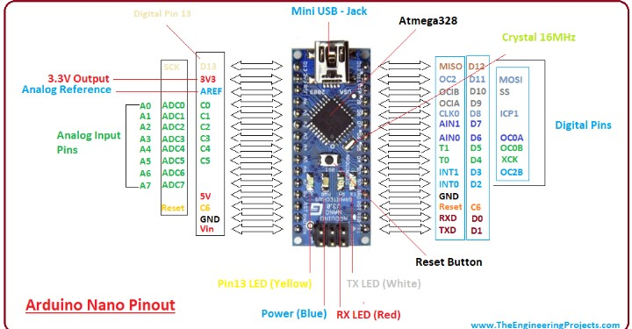

The Arduino microcontroller was used in this design because of the relative ease of programming and also because of its teaming community available online. (Appendix C)

The Arduino program was written in C++ language, compiled by the Arduino IDE windows program and uploaded into the chip via USB connection.

**The Current/Voltage Sensor (INA219)**

Close loop hall current sensors are a new generation of current sensor which applies hall effect principle, can measure direct current, alternating current, pulse and current of various irregular wave forms in electrical isolation conditions. Higher accuracy and linearity, short responding time and wide frequency band make it widely used in current monitoring devices, high current protection and other fields. The magnetic field produced by primary current Ip is balanced with the magnetic field produced by secondary coil current. The hall unit and auxiliary circuit produce secondary magnetic compensation current that can accurately response the primary current. This module was chosen because of the following:

• Wide frequency band • Excellent linearity • Good overall accuracy • No insertion loss • Quick response time • Low temperature drift

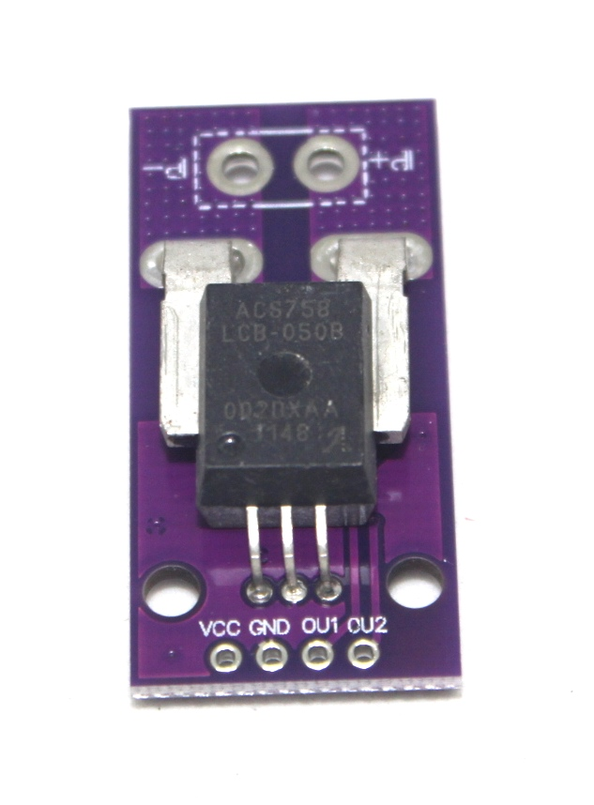

Figure 3.2: the current sensor

**The PV Module**

To serve as sensor and power supply a 5W solar panel compose of multi-crystal solar cell with an efficiency of over 17% is chosen. Solar PV Cell is a photoelectric device that when the surface is exposed to sunlight, there will create a potential (voltage) across the material. Solar PV Cell is a single junction P-N Semiconductor device; it applies the rules of I-V curve. There are 4 important terms in Solar PV Cell, the Open Circuit Voltage (Voc), Short-circuit Current (Isc), maximum operate voltage (Vmp) and maximum operate current (Imp). To cut everything short, Short-circuit Current (Isc) value is directly proportional to the intensity of sunlight as shown in figure. The chosen Talkers Energy rigid solar panels is constructed using a tempered glass front and a PVF backing to provide maximum protection from the most severe environmental conditions. The entire laminate is framed in a heavy duty anodized aluminum frame to provide structural strength which translates to both more wattage per square foot and lower mounting structure cost. The panel has the following parameters:

Output voltage, Max = 18V

Output Current, Max = 0.38A

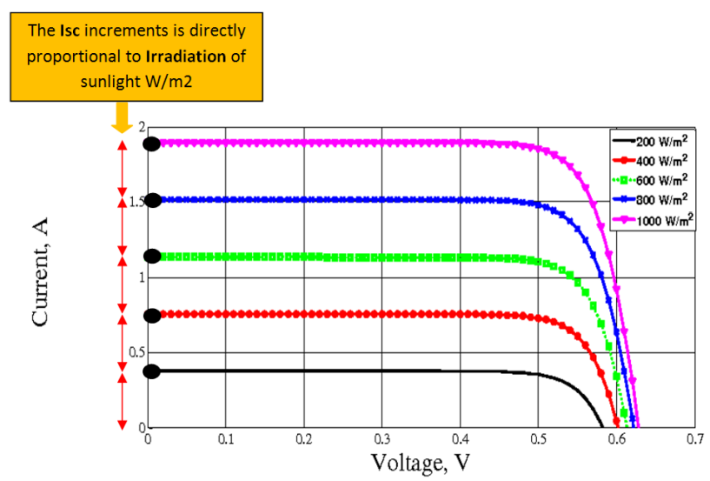

Figure 3.3: Graph of Short circuit current Isc vs Irradiation (Source: https:// www.researchgate.net)

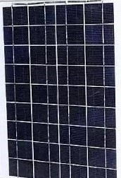

Figure 3.4: The PV panel

**The Power Supply Design**

The power supply to the sensing and transmitting unit is obtained from the PV module as sensor which is used to charge a 12V battery. The circuitry is as shown consisting of 5V regulator as output and an LM7812 regulator as charge control for the battery.

The IC 7812 will produce a fixed 12V at the output which cannot be used for charging a 12V battery. The 3 diodes connected at its ground (GND) terminals is introduced specifically to counter this problem, and to upgrade the IC output to about 12 + 0.7 + 0.7 + 0.7 V = 14.1 V, which is exactly what is required for charging a 12 V battery fully.

The drop of 0.7 V across each diode raises the grounding threshold of the IC by stipulated level forcing the IC to regulate the output at 14.1 V instead of 12 V.

The 2k2 resistor is used to activate or bias the diodes so that it can conduct and enforce the intended 2.1 V total drop.

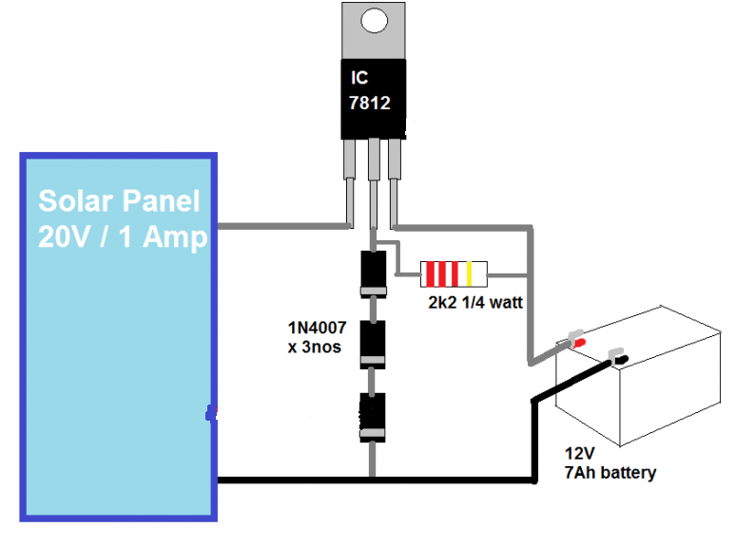

Figure 3.5: The charge control design

**The WIFI Module**

To be able to transmit the irradiance data wirelessly to the internet, an ESP8266 WiFimodule is required. Espresso’s ESP8266EX delivers highly integrated Wi-Fi SoC solution to meet users’ continuous demands for efficient power usage, compact design and reliable performance in the Internet of Things industry.

With the complete and self-contained Wi-Fi networking capabilities, ESP8266EX can

perform either as a standalone application or as the slave to a host MCU. When

ESP8266EX hosts the application, it promptly boots up from the flash. The integrated highspeed cache helps to increase the system performance and optimize the system memory.

Also, ESP8266EX can be applied to any microcontroller design as a Wi-Fi adaptor through

SPI/SDIO or UART interfaces. ESP8266EX integrates antenna switches, RF balun, power amplifier, low noise receive amplifier, filters and power management modules. The compact design minimizes the PCB size and requires minimal external circuitries.

Besides the Wi-Fi functionalities, ESP8266EX also integrates an enhanced version of

Tensilica’s L106 Diamond series 32-bit processor and on-chip SRAM. It can be interfaced

with external sensors and other devices through the GPIOs. Software Development Kit

(SDK) provides sample codes for various applications.

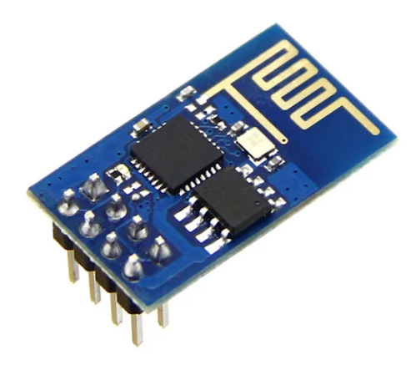

Figure 3.6: The WIFI module

**The Complete Circuit Diagram**

The individual component sections are put together to form the complete circuit diagram of the pyranometer and data receiver as shown in figure 3.5: and 3.6 respectively.



Figure 3.7: the pyrometer circuit

**3.3.1.2 The Mechanical Section Design**

Mechanical design begins from the body and electronic enclosure. In this research mechanical seasonal angle adjustments are provided in order to obtain an accurate direct normal irradiance measurement. Typically, the orientation of a surface is described by the zenith angle between the sunbeam and the normal of the area. If the surface area is not perpendicular to the sunbeam, a larger area is required to catch the same flow as the cross-section of the sunbeam. In figure 12 is shown how the hardware and enclosure box is integrated with the electronic part along with its dimensions. The electronic enclosure is designed to be tough and weatherproof since the instrument will be placed outdoors. The instrument is designed to be used in a long period throughout the seasons

The entire body will be made using weather proof plastic. It is tripod shaped where the photovoltaic panel will be mounted on the upper surface of the tripod. The upper part of the tripod is equipped with two adjusters for seasonal tracking of the sun’s position so that its surface will always be perpendicular to the solar irradiance. Similar electronic concept was developed to maximize solar panel efficiency (Tharamuttan, 2017).

Tilt angle

Flat Bed

Stand

Base

Pyranometer

*Figure 3.8: Instrument Design (Isometric View)*

**3.4 Software Design**

The code is designed to transmit a value which is derived from averaging 1000 samples in every second.Each sample is recorded every 1 milli second (0.001 second). With this, the fluctuation of value is way lesser compare to taking 1 sample reading every second, to ensure this the sensor cables would be made tight because minor movement of wires might effect on the wire terminal connections thus affecting the accuracy reading. All sensors that connected to analog input must be measured by voltage value. In order to provide the current value, the current sensor module is actually providing voltage value that related to measured current value. The analog input pins will map input voltages between 0 and 5V into integer values between 0 and 1023 with resolution of 4.9mV per unit (5.00V / 1024 units).

The current sensor utilizing hall-effect principle which voltage is produced from the movement of current within the region of magnetic field. The voltage produced by hall effect is directly proportional to the applied current making it suitable to estimate the applied current from the voltage sensed. The code will be written in C++ language and uploaded to the controller via the IDE.

**3.5 Method of Simulation**

Proteus was used in this work to, not only design the circuit diagram, but to also simulate the entire system. Hex codes copied from the Arduino IDE into the controllers in proteus, and also configurations made at the VSPE software completes all the stages required for the simulation in proteus to run properly. One of the components added in the simulation is a virtual serial terminal. Two virtual terminals were added. One to show data readings from sensor and the other to show data received. Both data are expected to be the same if the controllers are coded properly and if all processes, explained, required to complete the simulation are followed.

The designed circuit was drawn in proteus 8.0 software in windows 10 platform. All component and parameters were carefully chosen from the database.

Simulation of this work was achieved using four different software

**3.5.1 Virtual Serial Port Emulator (VSPE)**

In this simulation, a VSPE was used to simulate the wireless connection between the transmitting WIFI module and the WEB server Computers don’t communicate with the real world directly so they need a controller to help them communicate to the real world, interpret the data, and relay the data to them. The VSPE software also simulates the wireless communication between both modules used for the simulation.

In other to effectively simulate these connections, a communication port, usually referred to as COM port, needs to be established. The VSPE was used to establish this COM port.To establish a COM port, the software was started and the “create new device” icon is clicked. This is illustrated in figure 12.

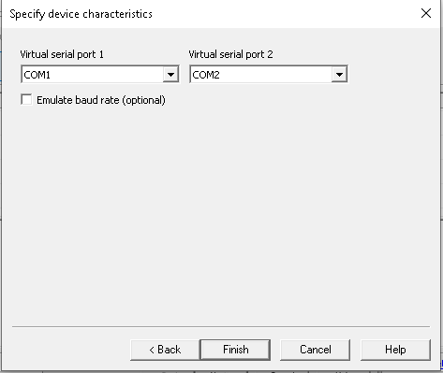

*Figure 3.9: COM1 and COM2 Simulation ports*

**3.5.2 Arduino Integrated Development Environment**

In this design, the Arduino nano was simulated in the proteus environment using Arduino virtual library for proteus. To achieve the simulation programs for the Arduino has to be written in the C programming language. These programs were written using the Arduino IDE. After writing and compiling the codes, the hex file was copied to the virtual Arduino library in proteus.

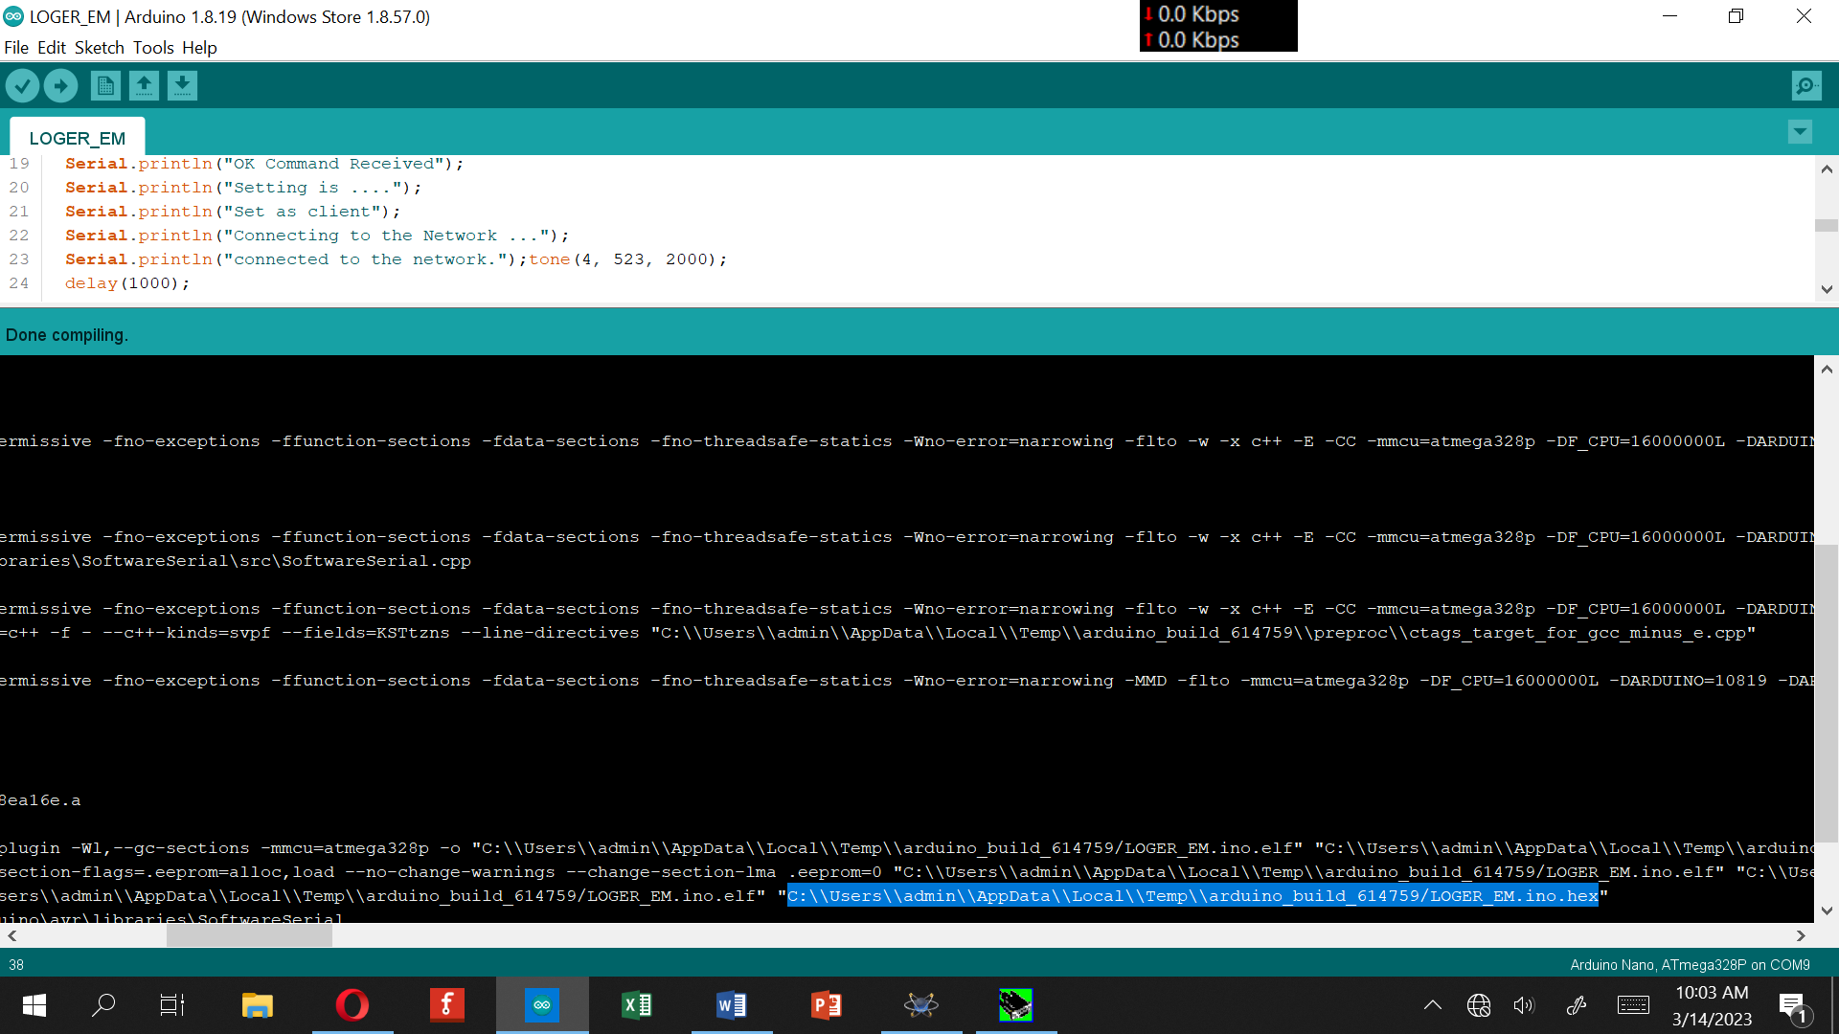

Figure 3.10: IDE showing the Hex file path

From figure 14 , the hex file copied, after compiling the codes, is show highlighted and the codes seen in the IDE is part of the codes written for the simulation. The full codes can be found in the appendix 1.

**3.5.3 Simulation Procedure**

The designed circuit was drawn in proteus 8.0 software in windows 10 platform. All component and parameters were carefully chosen from the database. Simulation was done under six different settings for solar intensity sensor.

1. Sensor at 100% setting
2. Sensor at 80% setting
3. Sensor at 60% setting
4. Sensor at 40% setting
5. Sensor at 20% setting
6. Sensor at 0% setting

Simulation starts when the following sequence of instructions are followed

1. Virtual serial Port emulator is started
2. Proteus is started

With simulation running, the sensor which is represented by a variable resistor is at default positions. The positions can be altered using the mouse.

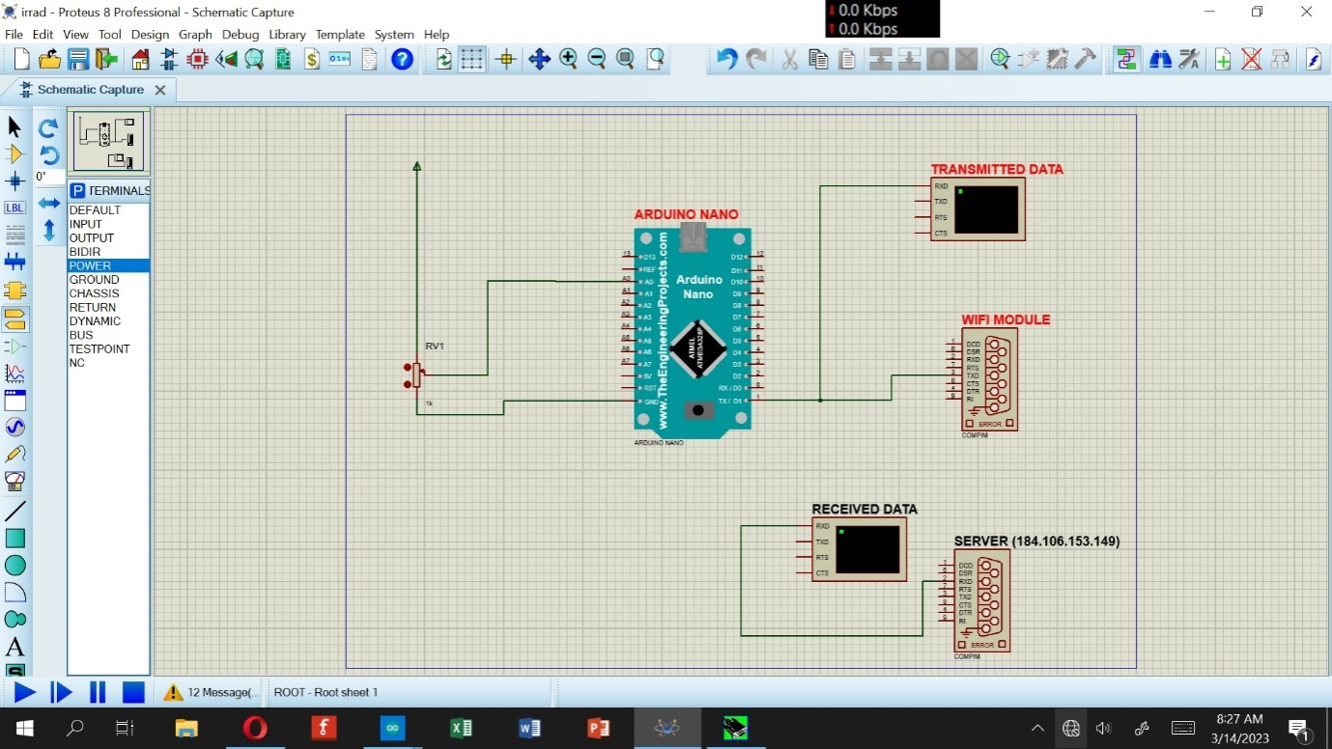 *Figure 3.11: Simulated Circuit Diagram*

**3.6 Method of Construction**

To simplify the construction procedures, the circuitry was segmented into functional blocks. The constriction included a prototype located on a breadboard followed by the final construction located on a Vero board. At each stage of the construction, a thorough test and assessment of the components and connection were carried out. The following steps were followed:

* The continuity and connectivity were taken using a mustimeter while the circuit was not
* powered;
* The construction was tested block by block;
* The measurement of capacitance, current, resistances and voltage were taken and compared with designed values.
* Dimensions were measured to exactness with the help of Vernier calipers and micrometer screw gauge.

**3.6.1 Permanent Construction**

After the proto boarding stage and testing the components were all removed and set for permanent construction on a pc board measuring 8cm by 4cm. The process for permanent construction includes soldering and packaging.

**3.6.2 Soldering**

Soldering is the process of joining two metals or wires to a metal using a soldering iron. The components are given a more general designated number which is almost consistent from one Vero board to another with soldering lead and care was taken not to use un-necessary long wires.

Care was also taken in soldering of all active components so as to avoid damage due to excessive heat.

A soldering iron having a low power rating of 40 watts at 250c was used to avoid dry joint and short circuit.

The following tools were used to accomplish the soldering and de-soldering task

i. Soldering iron

ii. Metal brush and file

iii. Lead

iv. long nose plier and wire cutter

v. Lead sucker

The Vero-board was cleansed with metal brush and lead of each component was measured and excess was cut off to avoid short circuiting care was taken to ensure that the components were fixed properly as shown in the schematic diagram.

**3.6.3 Data Logging**

To log the wirelessly transmitted data unto web server on Thigspeak website the following process is followed for obtaining a channelID as well as an application programming interface (API).

[1. Register](http://1.register/) on Thinkspeak



Figure 3.12: Thingspeak webpage



Figure 3.13: registering on Thingspeak

2. Create and save a new channel after registration to obtain a channel ID and an API key

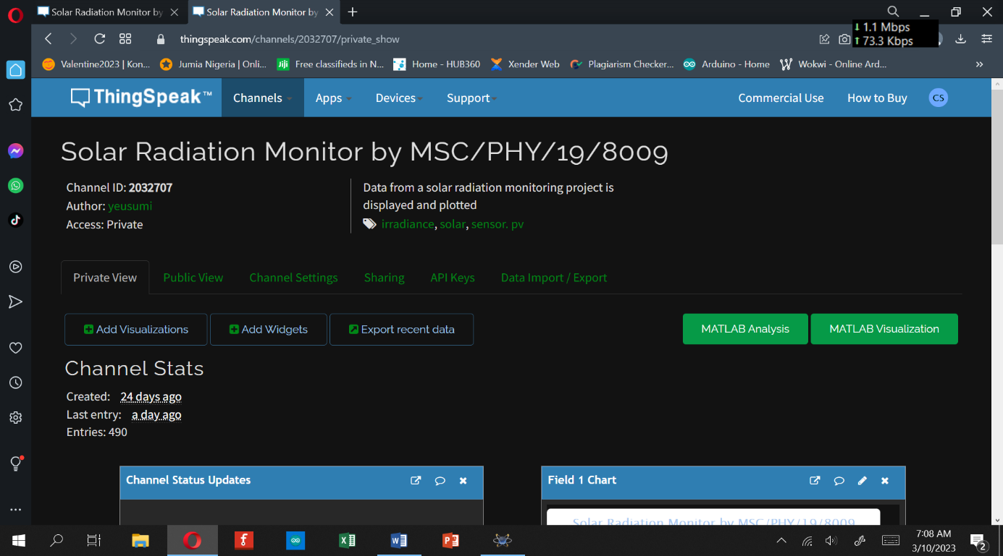

Figure 3.14: Registered channel

4. Copy the API key into the Arduino code as shown in figure



Figure 3.15: registration details

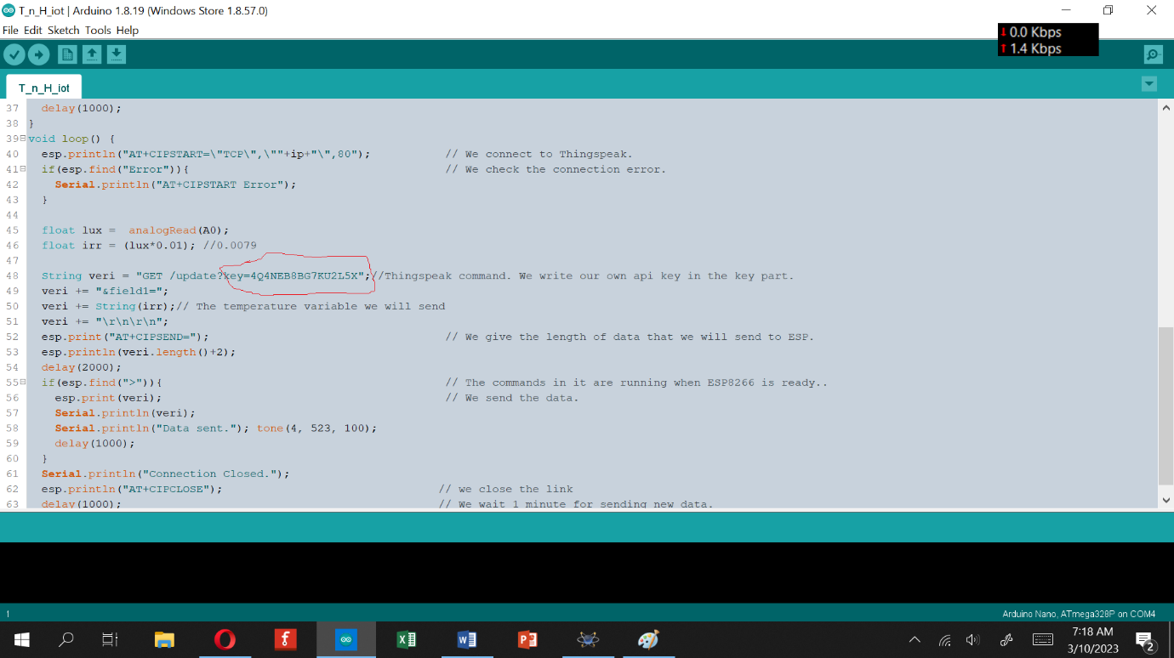

Figure 3.15: Inclusion of API key in the program code

**3.6.4 Packaging**

The completed pyranometer was cased in plastic container measuring 30cm x 12cm x 14cm.

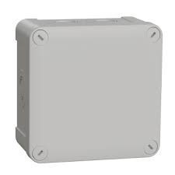

The stand measured 1m in height above ground, with attachment for adjusting elevation of the sensor.

**CHAPTER FOUR**

**RESULTS AND DISCUSSION**

**4.1 Design Result**

The different sections designed and or selected are put together to form the complete circuit diagram of the system. The circuit diagram is given in figure 10.

**4.2 Simulation Result**

Table 4.1: Summary of simulation result

|  |  |  |
| --- | --- | --- |
| S/N | CONDITION | IlluminanceIrradiance  LuxWatt/m2 |
| 1 | A (sensor =100%) | 1025 8.54 |
| 2 | B (sensor = 80%) | 925 7.70 |
| 3 | C (sensor = 60%) | 165 1.37 |
| 4 | D (sensor = 40%) | 800.66 |
| 5  6 | E (sensor = 20%)  0% | 32 0.25  0 0 |

**4.3 Construction Result**

After prototype testing the hardware was put together in an acrylic packaging as shown in figure 4.1 and figure 4.2.

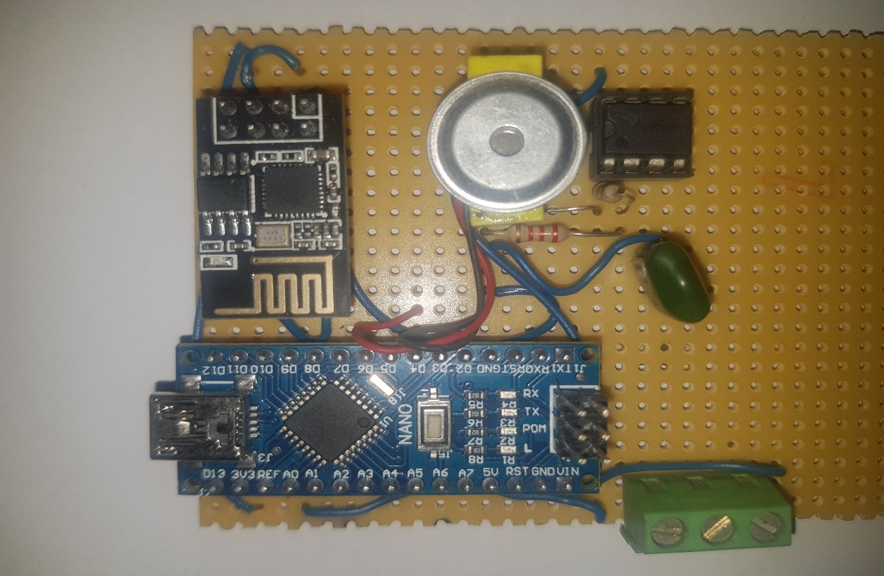

*Figure 4.1: Constructed Circuit*

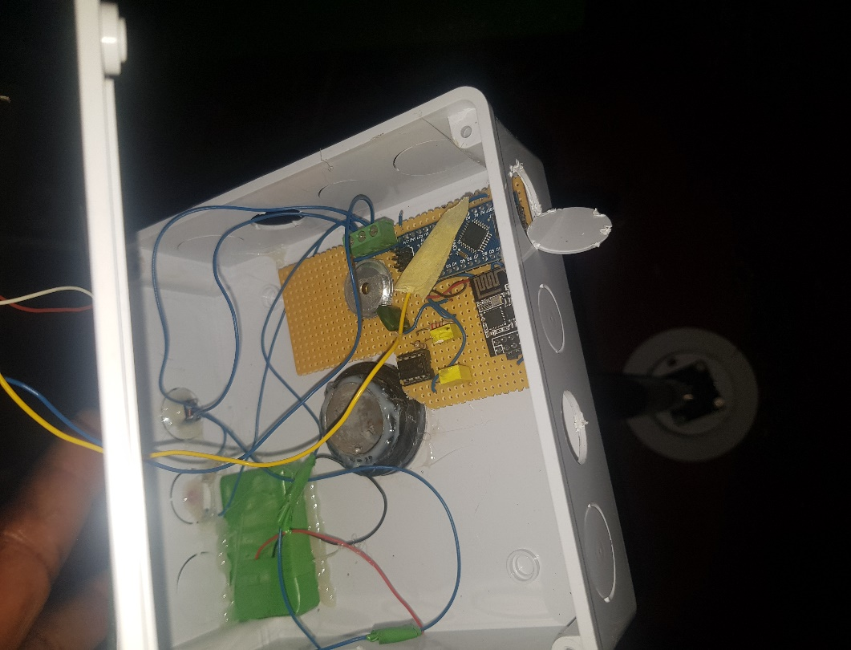

Figure 4.2: The casing showing the circuit

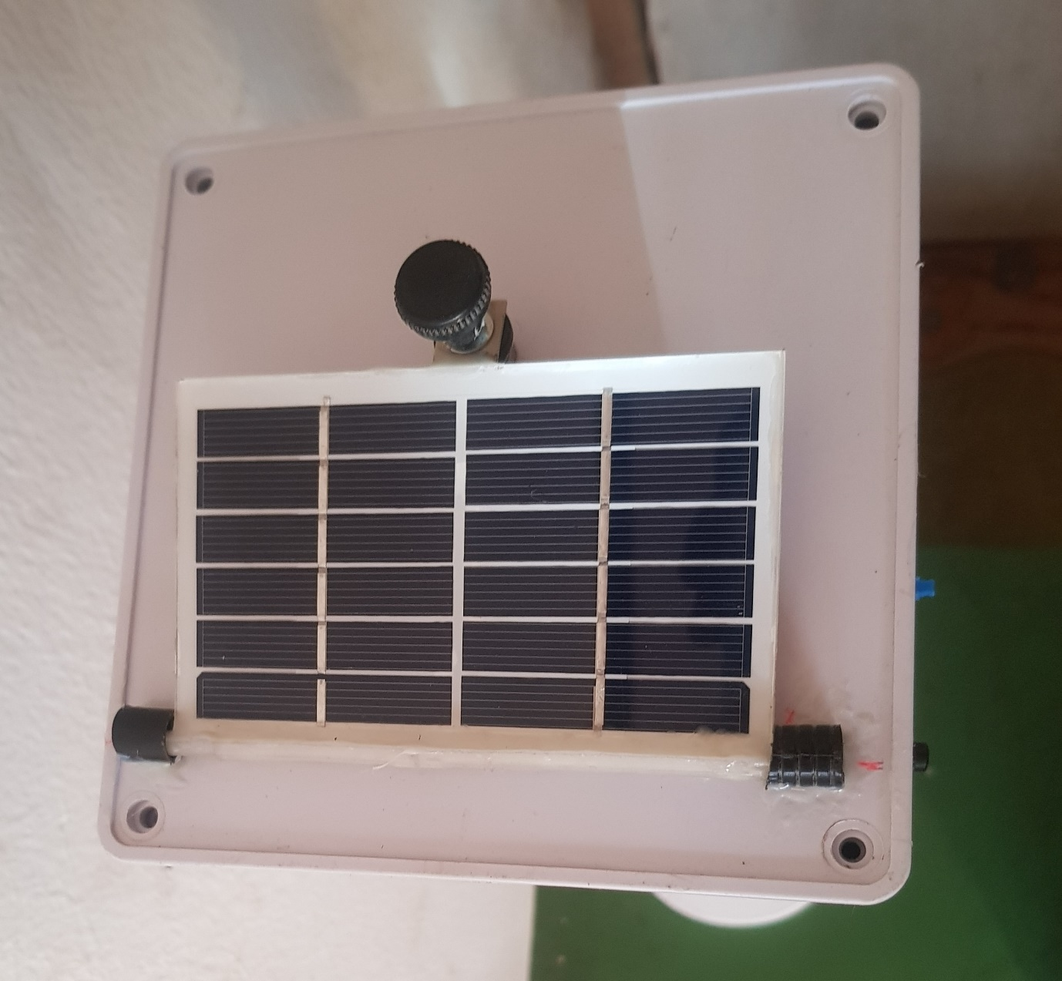

Figure 4.3: The cased Phyranometer

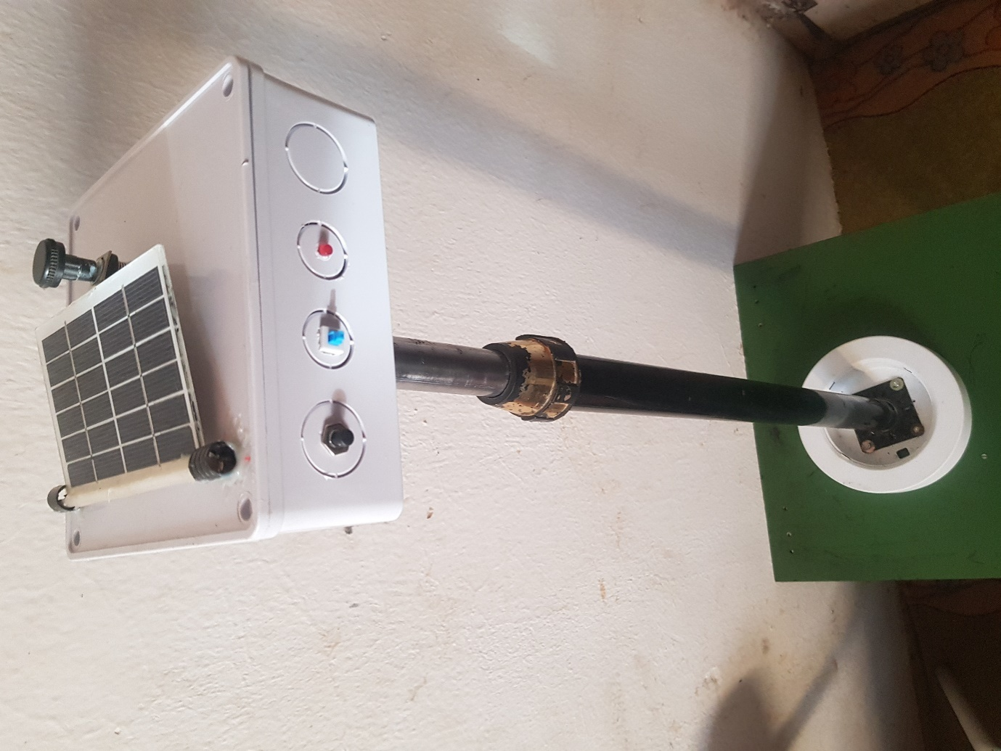

Figure 4.4: The construction showing the stand

**4.4 Performance Result**

The transmitted data was observed by logging unto the channel from any internet enabled browser or using the downloaded android application Thingview. The displayed results are as follows:

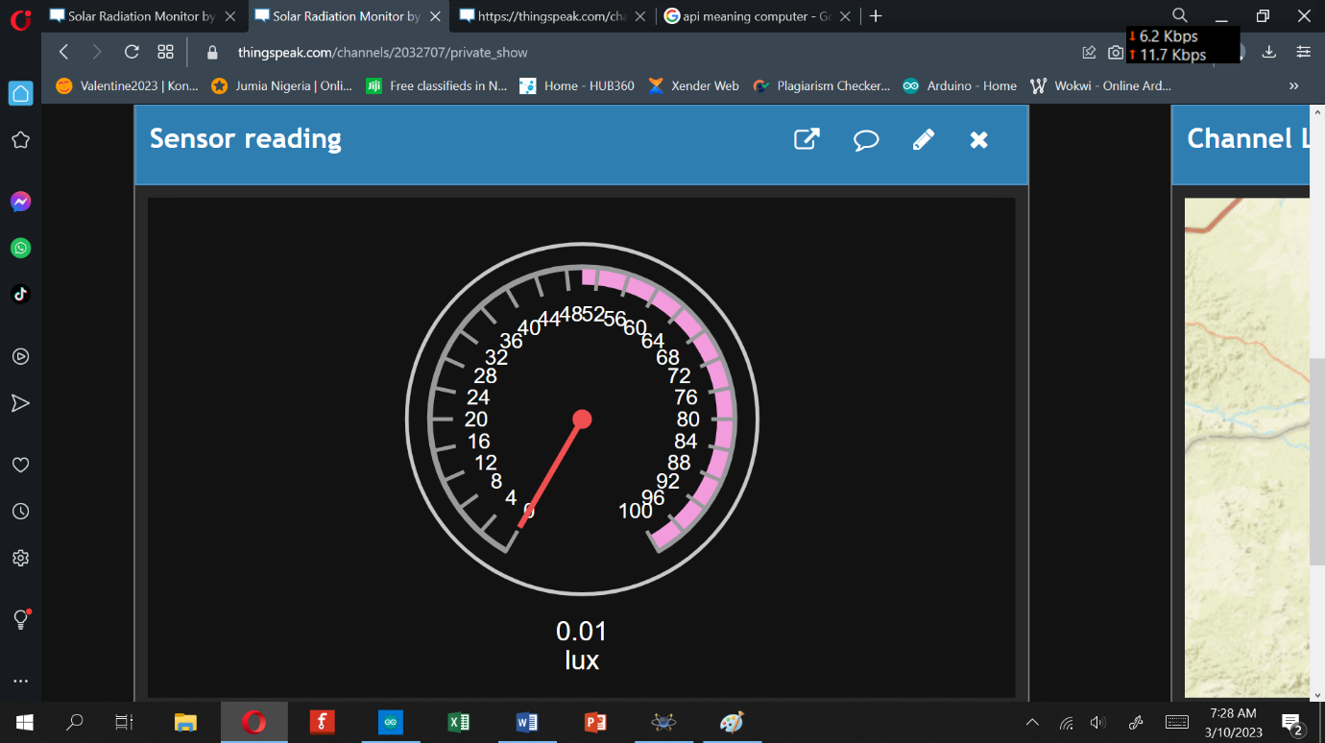

Figure 4.5: Raw sensor reading in Lux

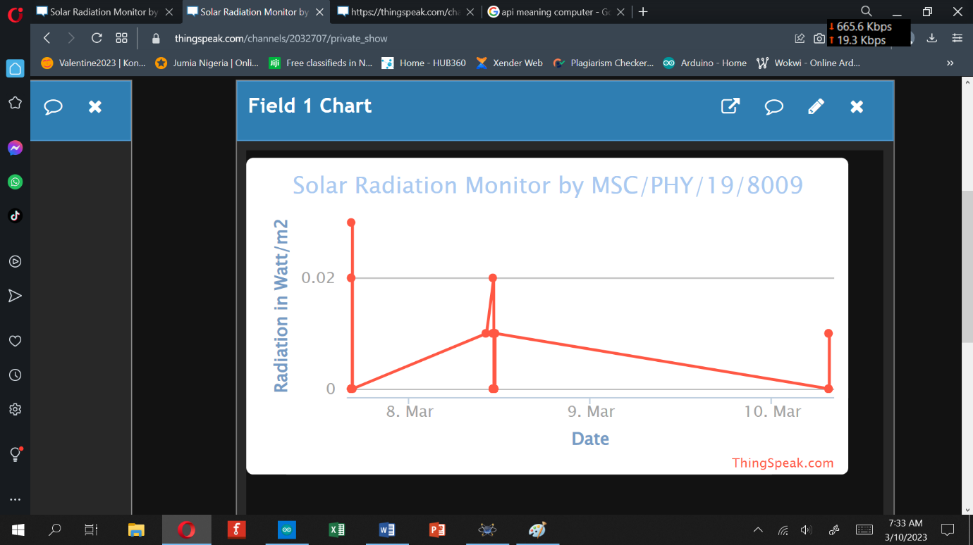

Figure 4.6: Graph of solar irradiance vs Time

Table 4.2: Sample Logged data reading from the web page

|  |  |  |  |
| --- | --- | --- | --- |
| Date/Time | Entry ID | Watt/m2 |  |
| 2023-03-07 11:55:43 UTC | 406 | 9.02 |  |
| 2023-03-07 11:55:59 UTC | 407 | 8.54 |  |
| 2023-03-07 11:56:21 UTC | 408 | 7.81 |  |
| 2023-03-07 11:56:42 UTC | 409 | 8.03 |  |
| 2023-03-07 11:57:00 UTC | 410 | 7.95 |  |
| 2023-03-07 11:57:24 UTC | 411 | 8.57 |  |
| 2023-03-07 11:57:40 UTC | 412 | 9.15 |  |
| 2023-03-07 11:58:03 UTC | 413 | 7.76 |  |
| 2023-03-07 11:58:27 UTC | 414 | 7.99 |  |
| 2023-03-07 11:58:45 UTC | 415 | 8.47 |  |
| 2023-03-07 11:59:00 UTC | 416 | 7.81 |  |
| 2023-03-07 11:59:25 UTC | 417 | 8.98 |  |
| 2023-03-07 11:59:52 UTC | 418 | 7.93 |  |
| 2023-03-07 12:00:09 UTC | 419 | 7.71 |  |
| 2023-03-07 12:00:25 UTC | 420 | 8.6 |  |
| 2023-03-07 12:00:50 UTC | 421 | 8.56 |  |
| 2023-03-07 12:01:24 UTC | 422 | 8.79 |  |
| 2023-03-07 12:01:44 UTC | 423 | 8.87 |  |
| 2023-03-07 12:02:01 UTC | 424 | 8 |  |
| 2023-03-07 12:02:53 UTC | 425 | 8.51 |  |
| 2023-03-07 12:03:09 UTC | 426 | 8.91 |  |
| 2023-03-07 12:03:41 UTC | 427 | 7.87 |  |
| 2023-03-07 12:03:58 UTC | 428 | 7.82 |  |
| 2023-03-07 15:15:29 UTC | 429 | 0.01 |  |
| 2023-03-07 15:15:46 UTC | 430 | 0 |  |
| 2023-03-07 15:16:12 UTC | 431 | 0 |  |
| 2023-03-07 15:16:38 UTC | 432 | 0 |  |
| 2023-03-07 15:16:53 UTC | 433 | 0 |  |
| 2023-03-07 15:17:16 UTC | 434 | 0 |  |
| 2023-03-07 15:17:32 UTC | 435 | 0 |  |
| 2023-03-07 15:17:48 UTC | 436 | 0 |  |
| 2023-03-07 15:18:33 UTC | 437 | 0 |  |
| 2023-03-07 15:19:00 UTC | 438 | 0 |  |
| 2023-03-07 15:19:16 UTC | 439 | 0 |  |
| 2023-03-07 15:19:37 UTC | 440 | 0 |  |
| 2023-03-07 15:19:59 UTC | 441 | 0 |  |
| 2023-03-07 15:20:16 UTC | 442 | 0 |  |
| 2023-03-07 15:20:46 UTC | 443 | 0 |  |
| 2023-03-07 15:21:43 UTC | 444 | 0 |  |
| 2023-03-07 15:22:00 UTC | 445 | 0 |  |
| 2023-03-07 15:22:18 UTC | 446 | 0 |  |
| 2023-03-07 15:22:51 UTC | 447 | 0 |  |
| 2023-03-07 15:23:28 UTC | 448 | 0 |  |

**4.5 Performance Validation**

The designed irradiance meter was set up in the same place and at the same time periods with a standard irradiance meter with a view to assessing its performance. The standard irradiance meter used was the Appogee solar radiation meter model MP-100 withstorage capability. Results obtained are given in table 4.2. The set up for validation is shown in figure 4.10.

Standard meter

Constructed meter

Figure 4.7: Validation test set-up, (the two systems are at same place and level)

Table 4.2: Validation Result

|  |  |  |  |
| --- | --- | --- | --- |
| S/N | Result of Constructed irradiance meter | Result of Standard irradiance meter (MP-100) | Difference |
| Irradiance in Watt/m2 | Irradiance in Watt/m2 |
| 1 | 167  226  298  445  547  599  606  699  750  800  2300  2670  4780  7850  10467  17000  19760  22340  25670  55600 | 158  220  292  443  538  590  599  697  750  802  2298  2668  4775  7852  10460  16995  19756  22338  25673  55598 | +9  +6  +7  +2  +9  +9  +7  +2  0  -2  +2  +2  +5  -2  +7  +5  +4  +2  -3  +3 |
| 2 |
| 3 |
| 4 |
| 5 |
| 6 |
| 7 |
| 8 |
| 9  10  11  12  13  14  15  16  17  18  19  20 |
|  |  |

**4.6 Calibration**

There is an observable difference between the measured solar irradiance readings and that of the standard readings. The maximum variance is +9W/m2 while the minimum variance is -2W/m2. To correct the reading average variance is added as factor in the program;

Average = (V1+V2+……..+V20)/20 =

= (9+6+7+2+9+9+7+2-0-2+2+2+5-2+7+5+4+2-3+3)/20

= 74/20 = 3.7

The value 3.7 is added to line 46 of the C++ program as shown in the diagram below.

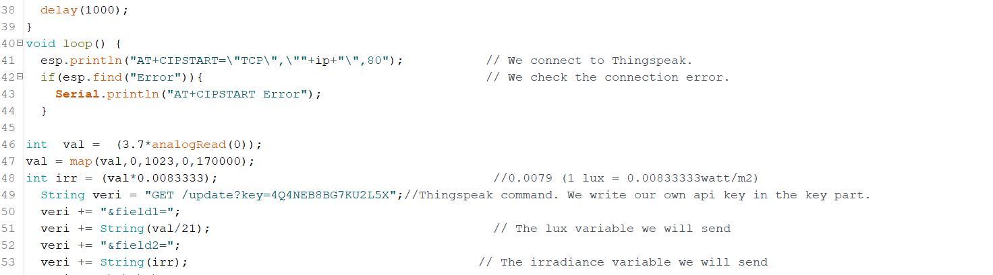

Figure 4.8: Soft calibration procedure

**4.7 Discussion**

From the irradiance simulation results figure 4.4- 4.12 the readings of irradiance displayed direction tally with the varying sensor positions. Though not accurate because the resistor is not varied accurately with the mouse. That is bringing the resistance to 0% does not necessarily mean the resistance the microcontroller is seeing under simulation is 0.

From logged data result Table 4.2 it can be seen that data was indeed logged on channel 2032707 on thingspeak webpage. The data is same with the one displayed on the graph shown in figure 4.14 indicating that solar irradiance was recorded and logged in real time. This is an indication of the wireless and data logging capability designed for the thesis.

Reading obtained from the validation test show a disparity between the constructed and the standard meter reading of a maximum of +9 and a minimum of -2. This variation is of course due to the fact that the PV panel used is not designed specifically for irradiance measurement and so it is nit calibrated.

After the calibration the readings obtained were observed to be same to the standard reading in most lower irradiance measurements and very close to the standard at higher irradiance readings indicating that the calibration was successful, but that the sensor used is most sensitive at lower irradiance values. This effect can best be taken care of by experimenting with different make of solar PV cells to determine their response spectrum before selection as irradiance sensor.

**CHAPTER FIVE**

**CONCLUSION AND RECOMMENDATIONS**

**5.1 Summary**

Photovoltaic system is one common alternative in reducing usage of fossil fuel to generate electricity. Photovoltaic system requires low cost of maintenance and is less location-dependent. However, the cost to install a photovoltaic system is relatively high. Furthermore, not all locations are suitable to build a photovoltaic system. Therefore, solar irradiance data is crucial in determining feasibility to install a photovoltaic system. In practical, solar irradiance data is collected using data logger and cannot be collected remotely. To tackle these problems, a cost saving irradiance data collection system which is able to perform solar tracking mechanism and IoT data collection, is designed and constructed. A solar PV cell with an Arduino Nano was implemented as the core in sensing solar irradiance, while ESP32 was implemented as the core in performing IoT data collection system. High precision current-to-voltage circuity for pyrheliometer were constructed in order to achieve accurate current reading from the PV cell, which will indirectly help in achieving high precision pyrheliometer.

From the performance of the system, it can be categorically stated that the following have been achieved:

i. A solar radiation sensor from available material was designed.

ii. An IOT data transmitter using a WIFI module was designed.

iii. Solar radiation detection and monitoring was simulated in Proteus software.

iv. The wireless solar radiation sensor was constructed and tested for performance appraisal.

This therefore show that the realized system can be used as a wireless solar radiation meter with data logger.

**5.2Conclusion**

In conclusion, the objectives of the project are achieved. A cost effective active cost saving pyrheliometer was constructed which can help to save a lot of cost to buy the actual solar meters. Furthermore, the constructed solar meter is much lighter and smaller compared to the actual solar meters. According to the comparison between constructed and actual pyrheliometer, the accuracy of constructed pyrheliometer was relatively high. To ensure the constructed solar meters to function as the actual meters, high precision voltage to current converter circuits are needed for the microcontroller to read accurate current values for conversion to respective solar irradiance values of the pyrheliometer. In this project, high precision current-to-voltage converter circuitry for the sensors were successfully built. The solar irradiance data can be collected and visualized remotely using any browser as long as ESP8266 connects to the Internet. Although all objectives in the project are achieved, there are several problems and challenges faced. Firstly, uncertainty in achieving high precision solar tracking mechanism is relatively high. Besides, the range of Wi-Fi network is relatively short for stable connection between ESP8266 and the source of network. Furthermore, Arduino IDE software was not flexible in IoT software development due to limitations of open-source libraries.

**5.3 Recommendations**

Based on the work presented in this report the following recommendations are hereby given to improve the work:

* One of the major problems faced when performing IoT data collection system is limited range of Wi-Fi network. Wi-Fi provides a small coverage of network (Guillemette, 2019). The strength of Wi-Fi signal can be affected and weakened if there are obstacles. To overcome these problems, cellular network is recommended for its wider network coverage. Furthermore, the connection of cellular network is much more stable compared to Wi-Fi network
* To include automatic tracking to the system so that the sensor will accurately track the sun and collect actual irradiance.
* To use 3D printer and CNC machines for producing the component parts of the sensor such as the vane and the cups to improve accuracy.
* To add data fields like current generated by the panel and total Wh/m2 /day

**REFERENCES**

Abreu, E., Canhoto, P. and Costa, M., (2019). Prediction of diffuse horizontal irradiance using

a new climate zone model,” *Renew. Sustain. Energy Rev.*, vol. 110, pp. 28–42, Aug. 2019.

Ahmad, D., Habibullah, L., Lidiawati, and Riska, Ekawita, K. (2021) A simple and inexpensive

irradiance monitoring system using photovoltaic panel

Ahmed, M., Biplob, S., Kazim, K., Md, A., and Muhibul, H. (2014). design and implementation

of a solar radiation meter using pv panel as a sensor. gub journal of science and engineering, volume 1, issue 1, july 2014

Aakanksha, P., kartik, H. and Priyanka, P. (2013). Photodiode Based Pyranometer.

International Journal of Advances in Science Engineering and Technology, ISSN: 2321-9009 Volume- 1, Issue- 1, July-2013.

Asiegbu, A. D., Echeweozo, E. O. (2014). Design, Construction and Calibration of a

SolarRadiation measuring Meter, Review of Advances in Physics Theories and

Applications, vol. 1, no. 1, pp. 1-8

Aurora, S., (2020). Types of irradiance.” [Online]. Available:

https://twitter.com/aurorasolarinc/status/1073641311369084930. [Accessed: 04-Jul-2020].

Benghanem, M. (2010). “A low cost wireless data acquisition system for weather station

monitoring,” Renew. Energy, 2010.

Bilbao, J., Román, R., Yousif, C., Pérez-Burgos, B., Mateos, D., and Miguel, A.(2015) “Global,

diffuse, beam and ultraviolet solar irradiance recorded in Malta and atmospheric component influences under cloudless skies,” *Sol. Energy*, 2015.

Christy, M. and Amudha, T. (2017). An Analysis of Global Solar RadiationEstimationTechniques. International Journal of Engineering Technology Science and ResearchIJETSRwww.ijetsr.comISSN 2394 – 3386Volume 4, Issue 8August 2017

Consults, E. &Onyemaechi, A (2023). Design Construction and Characterization of Improved

Local Pyranometer for the Measurement of Solar Intensity at Nsukka.. *Afribary*. Retrieved from https://afribary.com/works/design-construction-and-characterization-of-improved-local-pyranometer-for-the-measurement-of-solar-intensity-at-nsukka-2

Djen, C., Jingchun, Z., and W. Lin. (1994). Solar radiation and surface temperature in Shanghai

City and their relation to urban heat island intensity,” *Atmos. Environ.*, 1994.

Fernando, G. H., Robinson, F. M., Edward, F. V. (2014). Design of a Low-Cost Sensor for

Solar Irradiance

Guillemette, P., 2019. Battle of the IoT networks: Cellular versus Wi-Fi. [blog] 25 April 2019.

Available at: [Accessed 16 August 2019]

Hinckley, A. (2020). Pyranometers: What You Need to Know,” *Campbell*, 2017. [Online].

Available: https://www.campbellsci.com/blog/pyranometers-need-to-know. [Accessed: 21-May-2020].

John, C., Mahmood, M., Abubakar, B., Lawal, O.&., Kabir, S. (2019). *IOSR Journal of*

*Electrical and Electronics Engineering (IOSR-JEEE) e-ISSN: 2278-1676, p-ISSN: 2320-3331, Volume 14, Issue 3 Ser. III (May. – June. 2019), PP 24-30 www.iosrjournals.org*

Kipp, U. &Zonen, G., (2018) “CMP6 Pyranometer,”. [Online]. Available:

https://www.omniinstruments.co.uk/cmp6-pyranometer.html. [Accessed: 04-Jul-2020].

Laghrouche, L., Attaf, A., Ziani, R., and Ameur, S. (2010). Design of a Microcontroller Based

Automated Pyranometer. International Conference on Renewable Energies and Power Quality (ICREPQ’10) Granada (Spain), 23rd to 25th March, 2010

Macome*et al.,* (2009). Design, Construction and Characterization Of A Multiple Sensors Solar

Radiation Detector forIses.3Norwegian University of Science and Technology, Department of Physics, Norway.https://www.researchgate.net/publication/289325519_Design_construction_and_characterization_of_a_multiple_sensors_solar_radiation_detector_for_ises_2009

Martínez, M., Andújar, M., and Enrique, J. (2009). A new and inexpensive pyranometer for

the visible spectral range,” *Sensors (Switzerland)*, vol. 9, no. 6, pp. 4615–4634, Jun. 2009.

Mathew, Little. (2022). Low-Cost DIY Solar Irradiance Sensor design. Renewable energy

innovations. h<ttps://www.re-innovation.co.uk/docs/low-cost-diy-solar-irradiance-s>ensor-for-pv-system-monitoring/

Medugu, D. W., Burari, F. W., Abdulazeez, A. A. (2010). Construction of a Reliable Model

Pyranometer for Irradiance Measurements, African Journal of Biotechnology Vol. 9(12), pp. 1719-1725, 22.

Medugu D. and Yakubu D. (2011). Estimation of mean monthly global solar radiation in Yola

– Nigeria using angstrom model. Advances in Applied Science Research, 2011, 2 (2): 414-421

Muchamad, R. & Andi, A. (2021). Development of a solar radiation sensor system with

pyranometer. International Journal of Electrical and Computer Engineering (IJECE) Vol. 12, No. 2, April 2022, pp. 1385~1391 ISSN: 2088-8708, DOI: 10.11591/ijece. v12i2.pp1385-1391

Mugur C. Balan, Mihai Damian and Lorentz Jäntschi. (2018). Preliminary Results on Design

and Implementation of aSolar Radiation Monitoring System. *Sensors, 8*, 963-978

Mukaro, R., Carelse, F., and L. Olumekor,(1998). First performance analysis of a silicon-

cell microcontroller-based solar radiation monitoring system,” *Sol. Energy*, 1998.

Nick84, (2020).“Solar spectrum ita.”Available:

https://commons.wikimedia.org/wiki/File:Solar_spectrum_ita.svg. [Accessed: 04-Jul-2020].

Nwankwo, S.&Nnabuchi, M. (2015). Global Solar Radiation Measurement in Abakaliki

Ebonyi StateNigeria Using Locally Made Pyranometer.

Orsetti, C., Muttillo, M., Parente, R., Pantoli, L., Stornelli, V. and Ferri, G. (2016). Reliable

and Inexpensive Solar Irradiance Measurement SystemDesign. 30th Eurosensors Conference, EUROSENSORS 2016.Procedia Engineering 168 (2016 ) 1767 – 1770

Paola, A., David, N., Albeiro, C., &Dixon,S. (2019). Design and Implementation of an Uv

Radiation MonitoringSystem to The Neiva-Huila Municipality. International Journal of Energy and Environmental ResearchVol.3, No.2, pp.47-54, September 2015

Peter, Van der Bourgh (2020). Designing a Low-Cost Autonomous Pyranometer. University

of Twente project paper series. <https://essay.utwente.nl/82693/1/86293_Burgt_BA_EEMCS.pdf>

Rösemann, R. (2004). *Solar Radiation Measurement: From Sensor to Application in*

*Meteorology and Environment; an Overview of the State of the Art; UV - Visible Light - Infrared*, 2nd ed. Kipp&Zonen, Delft, 2004.

Solecki, W., Ibrig, H., Dan, k., and Fada, K. (2005), “Mitigation of the heat island effect in

urban New Jersey,” *Environ. Hazards*, 2005.

Stickler, G. (2011). Solar Radiation and the Earth System,” *Educ. Br.*, pp. 3–5, 2011.

Thekaekara, M. (1976). Solar radiation measurement: Techniques and instrumentation,” *Sol.*

*Energy*, vol. 18, no. 4, pp. 309–325, 1976.

Tohsing, K., Phaisathit, D., Pattarapanitchai, S., Masiri, I., Buntoung, S., Aumporn, O. and

Wattan, R. (2019). A development of a low-cost pyranometer for measuring broadband solar radiation. Siam Physics Congress 2019 (SPC2019): Physics beyond disruption society Journal of Physics: Conference Series 1380(2019) 012045 IOP Publishing

doi:10.1088/1742-6596/1380/1/012045

World Meteorological Organization, *WMO-No. 8 (2012). Guide to meteorological instruments*

*and methods of observation*. 2012.

APPENDIX 1: The program

|  |
| --- |
| #include <Adafruit_ESP8266.h>  #include <SoftwareSerial.h>  String agAdi = "Mynet"; // We write the name of our network here.  String agSifresi = "*1965Cynet#"; // We write the password of our network here.  int rxPin = 11; //ESP8266 RX pini  int txPin = 10; //ESP8266 TX pini  String ip = "184.106.153.149"; //Thingspeakipadresi float sicaklik, nem;dht11 DHT11;  SoftwareSerialesp(rxPin, txPin); // We make serial communication pin settings.  void setup() {  Serial.begin(9600); // We are starting our communication with the serial port.  Serial.println("Started");  esp.begin(115200); // We are starting serial communication with ESP8266.  esp.println("AT"); // We do the module control with the AT command.  Serial.println("AT sent ");  while(!esp.find("OK")){ // We wait until the module is ready.  esp.println("AT");  Serial.println("ESP8266 Not Find.");  }  Serial.println("OK Command Received");  esp.println("AT+CWMODE=1"); // We set the ESP8266 module as a client.  while(!esp.find("OK")){ // We wait until the setting is done.  esp.println("AT+CWMODE=1");  Serial.println("Setting is ....");  }  Serial.println("Set as client");  Serial.println("Connecting to the Network ...");  esp.println("AT+CWJAP=\""+agAdi+"\",\""+agSifresi+"\""); // We are connecting to our network.  while(!esp.find("OK")); // We wait until it is connected to the network.  Serial.println("connected to the network.");tone(4, 523, 1000);  delay(1000);  }  void loop() {  esp.println("AT+CIPSTART=\"TCP\",\""+ip+"\",80"); // We connect to Thingspeak.  if(esp.find("Error")){ // We check the connection error.  Serial.println("AT+CIPSTART Error");  }  float lux = analogRead(A0);  float irr = (lux*0.01); //0.0079  String veri = "GET /update?key=4Q4NEB8BG7KU2L5X";//Thingspeak command. We write our own api key in the key part.  veri += "&field1=";  veri += String(irr);// The temperature variable we will send  veri += "\r\n\r\n";  esp.print("AT+CIPSEND="); // We give the length of data that we will send to ESP.  esp.println(veri.length()+2);  delay(2000);  if(esp.find(">")){ // The commands in it are running when ESP8266 is ready..  esp.print(veri); // We send the data.  Serial.println(veri);  Serial.println("Data sent."); tone(4, 523, 100);  delay(1000);  }  Serial.println("Connection Closed.");  esp.println("AT+CIPCLOSE"); // we close the link  delay(1000); // We wait 1 minute for sending new data.  } |

APPENDIX 2: ESP8266 WIFI Module Specifications

